IPv6 Configuration and Subnetting Assignment
1. Assign a Static IPv6 Address and Verify Configuration
Windows Steps:
1. Open Command Prompt as Administrator.
2. Run: netsh interface ipv6 show interfaces
3. Assign IPv6:
netsh interface ipv6 add address "Ethernet" 2001:db8:1::10
4. Verify using: ipconfig
Simple Diagram:
Router (2001:db8:1::1)
|
|
PC (2001:db8:1::10)
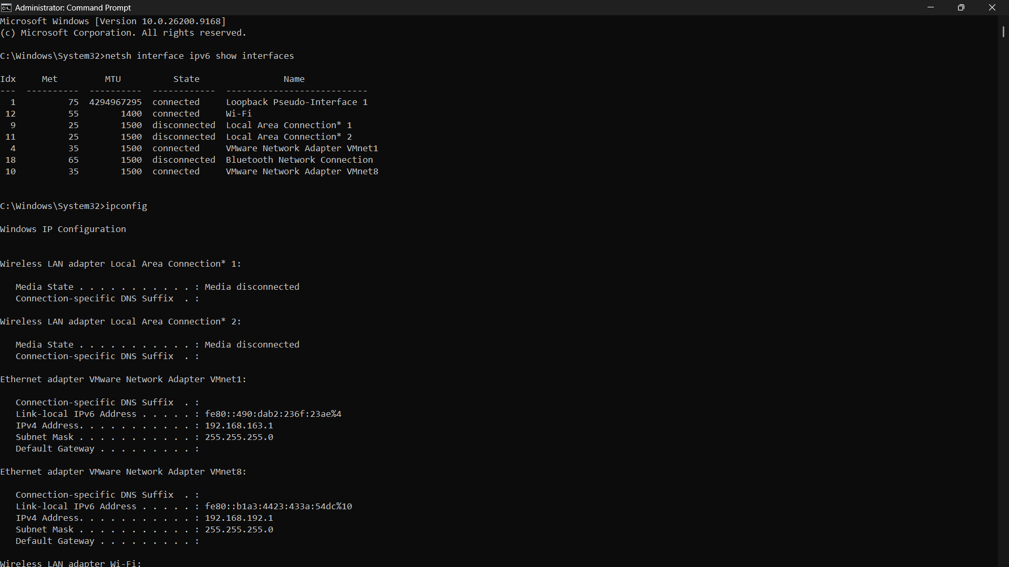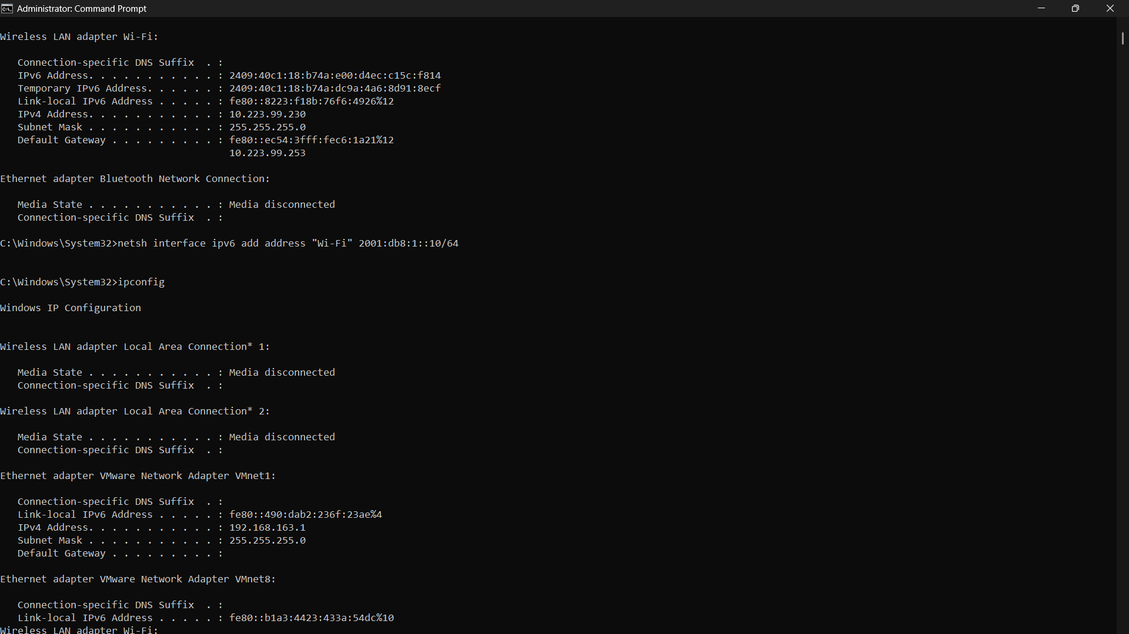
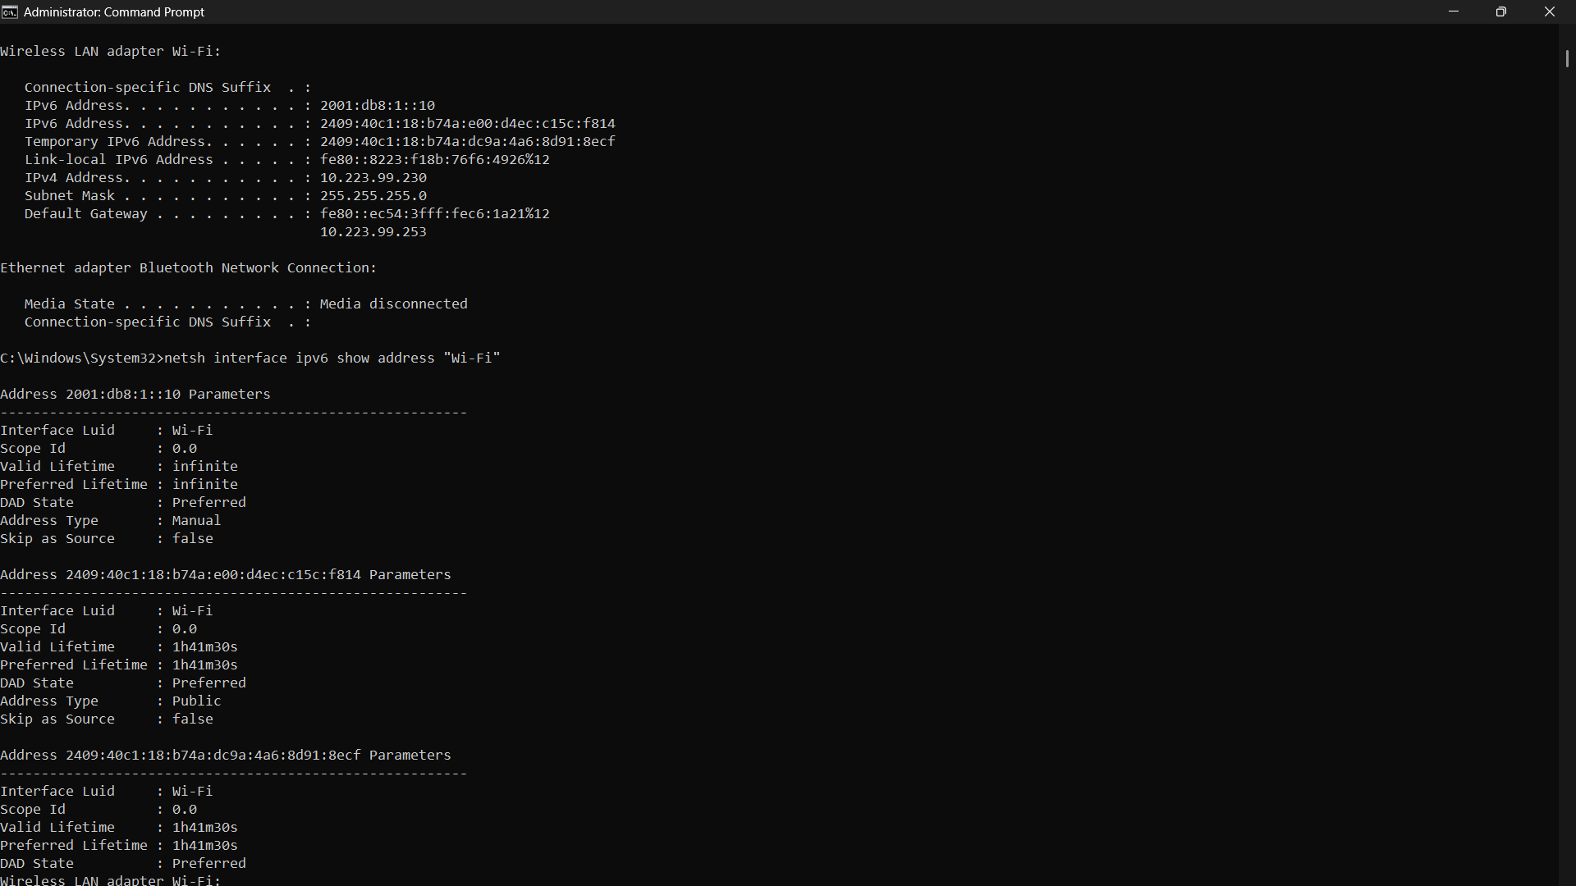
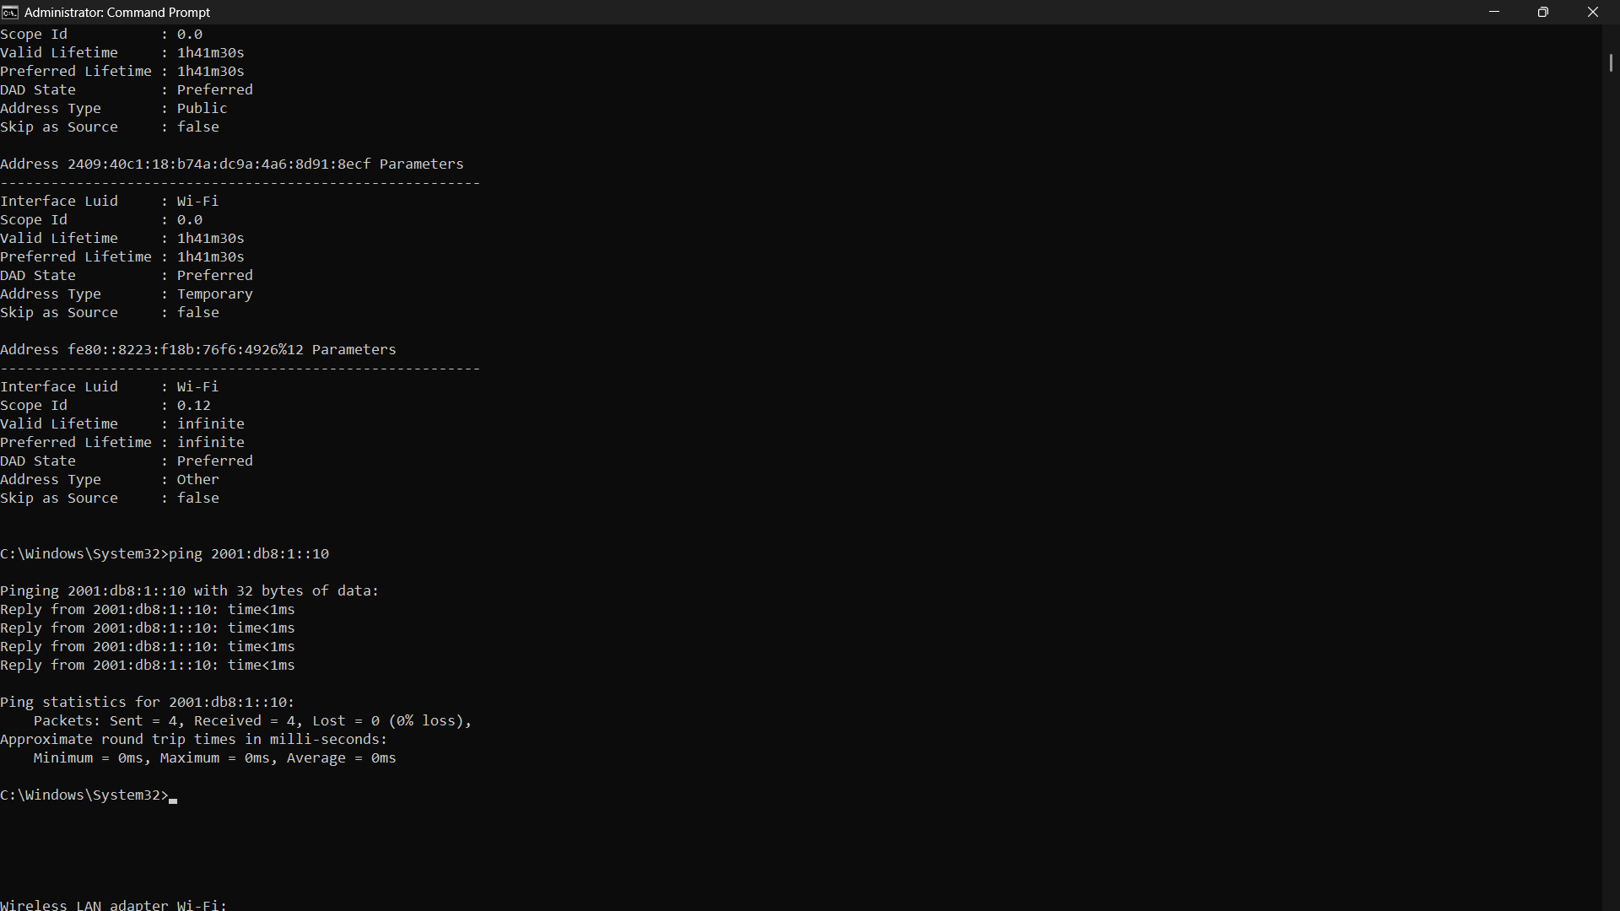
2. Configure a Unique Local IPv6 Address
Unique Local IPv6 Address:
fd00:1234:5678:1::10/64
Verify:
ipconfig
Ping another device:
ping -6 fd00:1234:5678:1::20
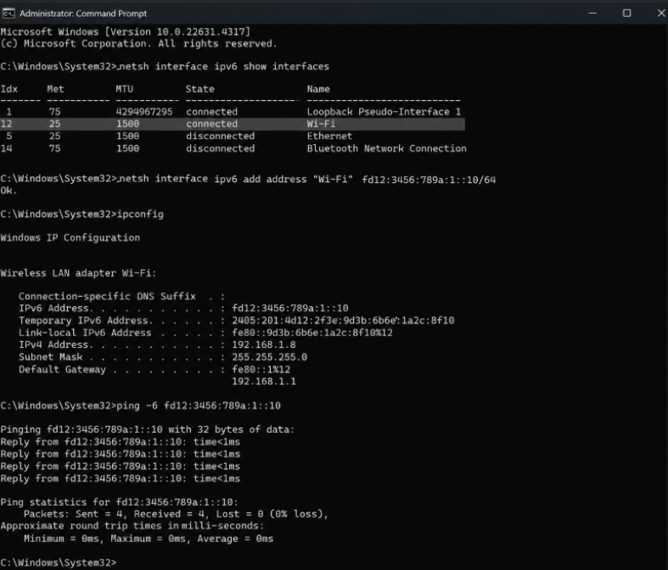
3. Temporary IPv6 Address Test
Steps:
1. Run ipconfig and note temporary IPv6 address.
2. Reboot or reconnect network.
3. Run ipconfig again.
4. Compare addresses.
Observation:
Temporary IPv6 address changes after reconnect or reboot.
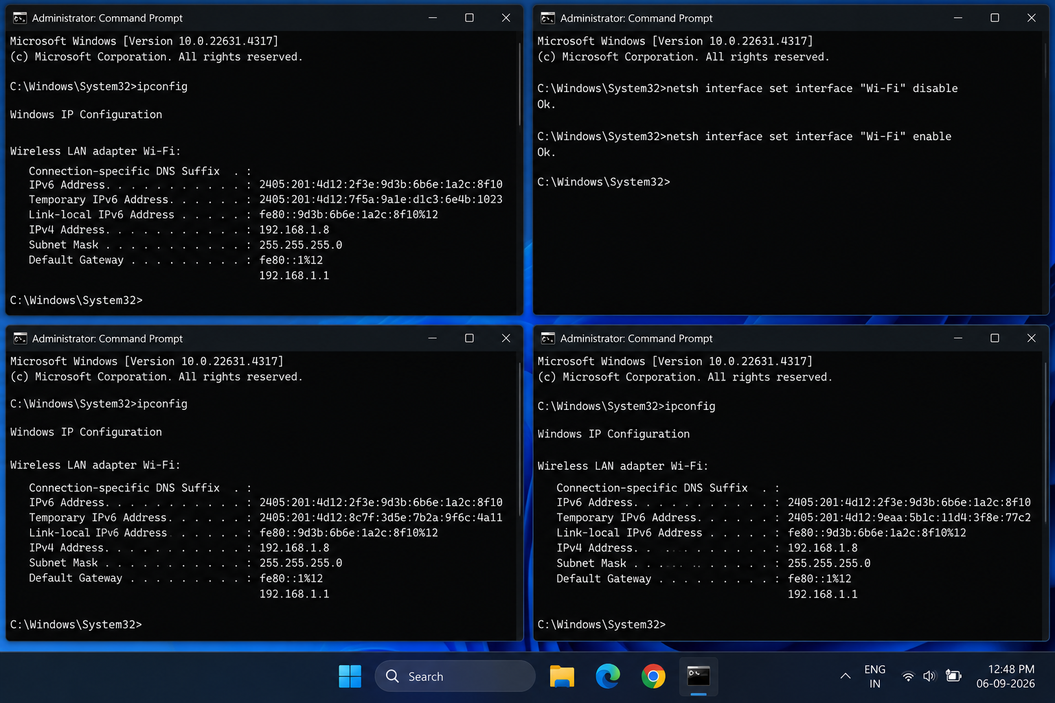
4. Restaurant IPv6 Search Program (Python)
restaurants = {
"Dominos": "2001:db8:1::10",
"Pizza Hut": "2001:db8:1::20",
"McDonalds": "2001:db8:1::30",
"Burger King": "2001:db8:1::40"
}
search = input("Enter restaurant name: ").lower()
for name, ip in restaurants.items():
if search in name.lower():
print(name, ip)
5. AI Generated IPv6 Subnetting Scenario
Delivery Team : 2001:db8:100:1::/64
Restaurants : 2001:db8:100:2::/64
Admin Team : 2001:db8:100:3::/64
Assigned Address:
2001:db8:100:1::50
Gateway:
2001:db8:100:1::1
Conclusion:
This assignment demonstrates IPv6 configuration, unique local addressing,
temporary addresses, IPv6 scripting, and subnetting.

